NHS App FAQ’s

What is the NHS App?
The NHS App allows you to access a range of NHS services. It is an easy-to-use app which allows you to manage your health in one place.
Who can use the NHS App?
To use the NHS App or log in through the NHS website you must be:
- Aged 13 or over
- Registered with an NHS GP surgery in England or the Isle of Man
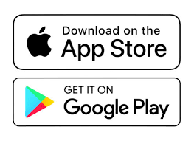
Where can I download the NHS App?
If you have an Apple device (iPhone or iPad), you can download the app on the App Store.
If you have an Android device (Samsung Galaxy, Huawei, Google Pixel etc), you can download the app on Google Play.
How do I sign up once I have the app?
Once you have downloaded the NHS App, you will need to set up your NHS login if you have not already got one.
You will need one of the following photo IDs to set this up:
- a passport
- a UK driving licence (full or provisional)
- a European driving licence (full)
- a European national identity card
If you do not have one of these, contact your GP surgery and ask to be registered for online services. They will then provide you with Linkage Key (could be called Passphrase), ODS Code (could be called Organisation Code or Practice ID), Account ID. You can use these 3 registration details to prove who you are instead of using photo ID for the NHS App.
What can I do with the NHS App?
You need to prove who you are to get full access to the NHS App. Some of the features below depend on your GP surgery.
- Get health advice using the health A-Z on the NHS website and using NHS 111 online
- Choose your organ donation preferences
- Access your COVID-19 vaccination record via GOV.UK
- Find NHS services nearby
- Order repeat prescriptions and view, set or change the pharmacy you want to collect your prescriptions from (known as your nominated pharmacy)
- View your GP health record securely
- Manage your first hospital or clinic appointment with a specialist, if you are referred by your GP through the NHS e-Referral Service
- Sign up for updates about participating in health research
- Book, cancel or change appointments.
- View and manage hospital appointments.
- Message your GP surgery or a health professional online

Can I ask a carer or family member to register on my behalf?
Yes, family members and carers can, with your consent, register on your behalf. However, they should not use their own email account to do this.
If you want the family member or carer to have access to your record, they can be added in the "sharing" section. This will allow them to set up their own account and allow you to control the level of access they have to your record.
Your GP also needs to register you for proxy access – please speak to your reception team about this.
Can I choose whether to have my notifications on or off?
Yes, however it is recommended to have notifications switched on as it is a convenient and secure way to get appointment reminders and other messages from your GP surgery. To manage your notifications:
- Log in to the app.
- Go to More.
- Select Account and settings.
- Then select Manage notifications.
- Use the toggle to turn notifications on or off.
Can I use the same log-in as my partner/spouse to log in?
No, you can't use an email address that's shared with someone else.
How do I know my data is secure?
Your information is stored securely, in a way that follows the NHS App Security and Privacy Policy
Your personal information is used to confirm your identity and set up your NHS login. Your NHS App then securely connects to information from your GP surgery.
If your device supports fingerprint detection or facial recognition, you can use it to log in to your NHS App each time, instead of using a password and security code.
Can the NHS App be used outside of the UK?
If you are registered with a GP surgery in England, you can use the app anywhere outside of the UK.
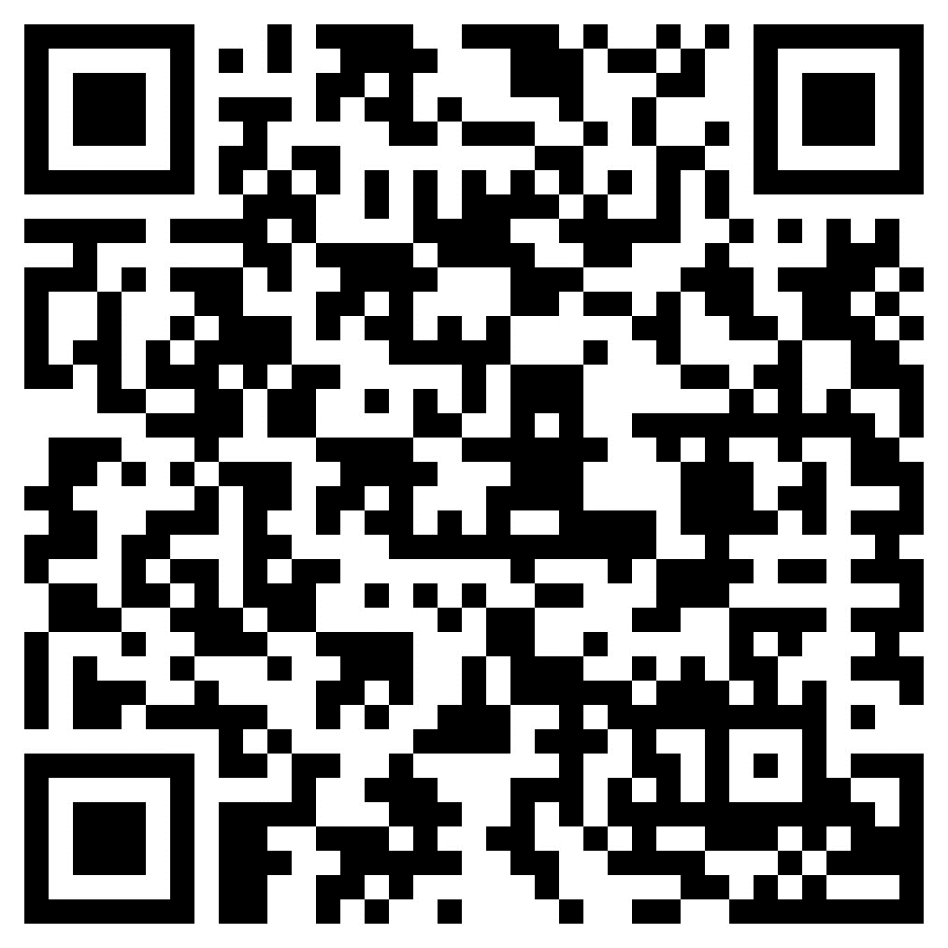
I have found a problem with a feature of the NHS App, who do I tell?
Problems with the NHS app can be submitted to NHS Digital directly using this link or scanning this QR code- https://www.nhs.uk/contact-us/nhs-app-contact-us

How do I change my NHS login details i.e. mobile number, email address or password?
Updating your NHS record details with your GP surgery will not change your NHS login details. You can add, or correct, the email address or mobile phone number on your NHS record by logging in using the NHS App or through the NHS website. If you need further support with this, contact the NHS Digital team directly using the QR code or weblink above.

